Comp 4735

Lab Instructor: _______________ SET : 4D

Name: Leon Ho & Jens Christiansen Signature: __________________________________

Lab 1

Solve the following exercises. Work in pairs. Discuss each exercise with your lab instructor.

- Watch the animation from: https://www.youtube.com/watch?v=04UGopESS6A
- Identify registers and their roles
- Follow the animation and discuss the outcome
- Observe the content of registers during each operation

- Consider a hypothetical machine with three instructions (pages 12 – 13 textbook):
0001 = Load AC from memory
0010 = Store AC to memory
0101 = Add to AC from memory
Consider the 16 bits instruction format as 4 bits for opcode and 12 bits for address
Consider a program that adds the contents of the memory word at address 940H to the contents of the memory word at the address 941H and stores the result in the later location.
The address of the first instruction is 300H.

Follow the execution of this program using the Figure 1.4.

- Consider the hypothetical machine:

Instruction Format: 16 bits (bits 0 to 3 for the opcode; 4 to 15 for the address)
- Integer Format: sign magnitude (bit 0 for the sign; 1 to 15 for the magnitude)
- Integer Format 2’s complement

PC: Program Counter
IR: Instruction Register
AC: Accumulator

Partial list of opcodes:

0001 Load AC from memory
0010 Store AC to memory
0100 Add AC and R1, result will be in AC
0101 Add to AC from memory address
0111 Load register R1 from memory
0110 Load AC from I/O
1000 Store AC to I/O
1001 Move R1 to AC

Write a small program that loads data from memory in accumulator or register 1, adds data and store data in the memory. Trace the execution as you did for the previous problem.

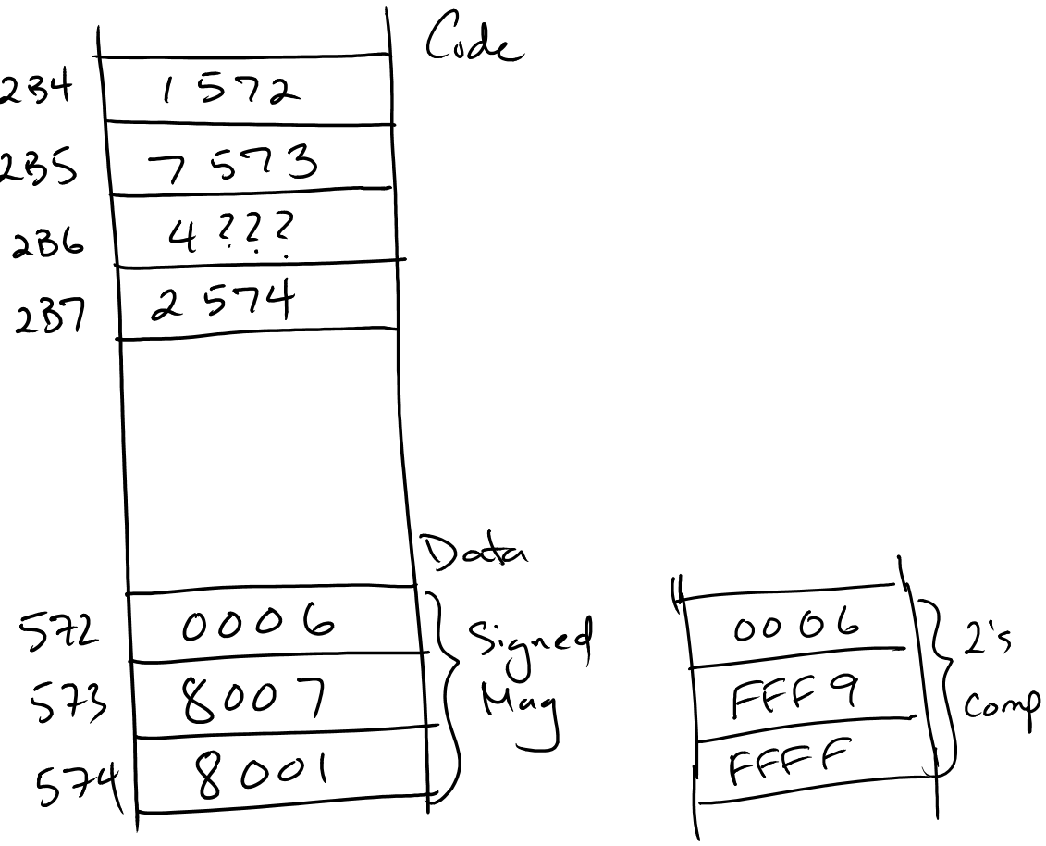

- What is a heap? What is the role of the heap? Who manages the heap?

The heap is memory space which holds program data. It is non-temporary storage of data that is needed for the application to execute. It is allocated by the OS, but the programmer manages it. In .NET, the CLR manages the heap; in Java, the JVM manages it.

- What is a stack? What is the role of a stack? Who manages the stack?

The stack stores temporary data like local variables inside of a function and passed parameters. The system performs various operations here. It is created and managed by the OS.

- How are function/method’s parameters passed to the stack?

- The function with the opcode and addresses for each parameter is passed to the program counter
- The address of the next instruction is pushed onto the stack.
- The parameter values are pushed onto the stack.
- The address of the return is pushed onto the stack.
- Any temporary variables in the code are pushed onto the stack.
- The function is executed. The stack pops off any unnecessary variables.
- If there is a return value, it is popped off to the return address.

- Discuss value, pointer and reference types.

Values are pushed directly onto the stack. Pointers and references only have their addresses pushed onto the stack.

A pointer has its own address in memory. A reference shares the same memory address.

A pointer can be reassigned, whereas a reference cannot.

